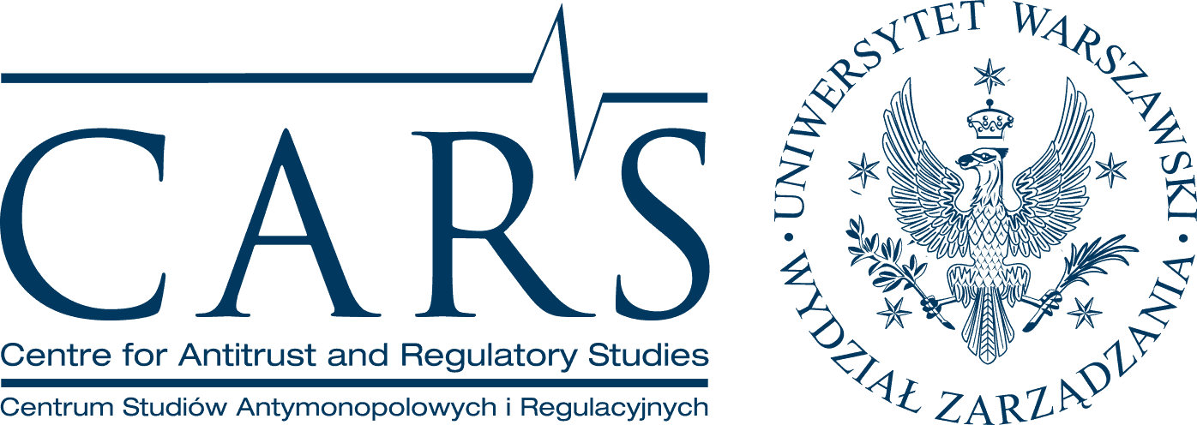

Call for Interest

Centre for Antitrust and Regulatory Studies at the University of Warsaw (CARS), a leading Central-European research institution in the area of competition law and policy as well as sector-specific regulation, is looking for potential candidates ready to undertake research and teaching in Warsaw, Poland. We will be launching a competition for a full-time position of Assistant Professor (in Polish: adiunkt). A PhD (or a completed PhD thesis) in law or economics and proficiency in English will be required. Previous research experience and international publications in English will be an advantage. Prior teaching experience is not necessary. The knowledge of Polish will not be required. Successful candidate will be expected to conduct high quality research, seek external research funding and actively support CARS activity.
The Centre will provide assistance with Visa formalities (for non-UE candidates) and contribute in covering the costs of moving to Poland. Remuneration will be set in accordance with the University of Warsaw’s pay grid and depending on knowledge, skills and experience of the candidate is likely to correspond to average national salary. Successful candidates will have the possibility to earn additional income by participating in the Centre’s externally commissioned research projects. The Centre will also offer assistance in applications for state-funded grants and scholarships for young scholars.
Potential candidates are kindly asked to contact Dr Maciej Bernatt, mbernatt@wz.uw.edu.pl to learn more about recruitment process and expectations. You can read about CARS at http://www.cars.wz.uw.edu.pl/news_gb.html For University of Warsaw see http://en.uw.edu.pl/

