YEARBOOK of ANTITRUST and REGULATORY STUDIES
Call for papers  YARS 2018 vol. 11(18) | 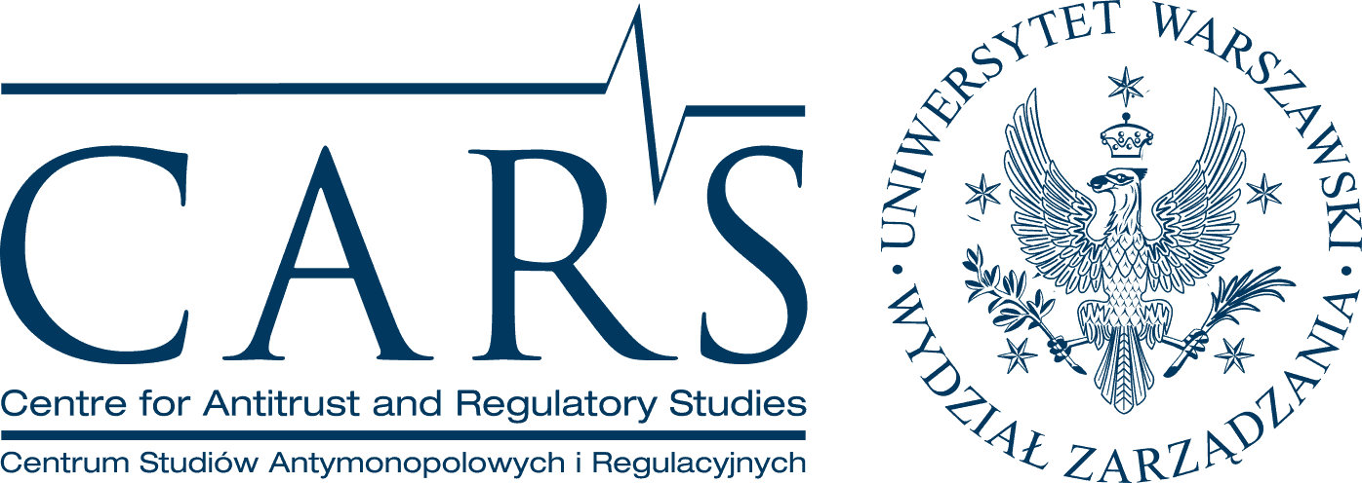
Academics, PhD candidates and practitioners are invited to submit research and critical papers that refer to law & economics of competition and sector-specific regulation (energy, electronic communications, post, transport, media) for YARS 2018, vol. 11(18).  Yearbook of Antitrust and Regulatory Studies (YARS) (ISSN 1689-9024, www.yars.wz.uw.edu.pl) is a double peer-reviewed, open-access academic journal, focusing on legal and economic issues of antitrust and regulation. YARS is published by the Centre for Antitrust and Regulatory Studies (CARS) of the University of Warsaw since 2008. | Expression of interest to publish: by 1 April 2018  Submission deadline: by 1 June 2018  Submissions should be sent to:  Maciej Bernatt (Editor-in-Chief, Volume Editor): mbernatt@wz.uw.edu.pl and Adam Jasser (Volume Editor), ajasser@wz.uw.edu.pl
Contributions may focus on
■ antitrust rules & case-law
■ state aid
■ pro-competitive regulation in a sector of energy, telecommunication, transport, digital services, postal services, etc.
■ economics of antitrust and sector-specific regulation|

Contributions focused on the developments in the post-transition countries (for example of Central and Eastern Europe) as well as on the developments in the mature competition law regimes (including the EU) of relevance for these countries are particularly welcome.

YARS accepts
■ articles (the focus is on critical review of both speculative research and practice-based research in law & economics) |
■ reviews of national legislation and jurisprudence in antitrust and sector-specific regulation in 2016-2018 |
■ comments to crucial judgments or antitrust/regulatory decisions issued in 2016-2018 including EU courts case-law |
■ book reviews |
■ reports of research and scientific activities in 2017-2018 (e.g. conferences, seminars, research projects) |
Submission of papers
The interest in submitting a paper should be expressed by 1 April 2018. The final papers should be submitted by 1 June 2018. Submissions must include: author’s name, home institution, title of the paper, table of contents, full text of the article, abstract, keywords and JEL classification.
The maximum length of the article is 9,000 words. All the contributions should meet standards of APA referencing system. A brief description of CMS can be found here: http://libguides.williams.edu/citing/apa.
To learn more you can visit YARS website: www.yars.wz.uw.edu.pl
Review process
Submitted articles will undergo a double, anonymous and independent peer-review process.

| Centre for Antitrust and Regulatory Studies (CARS) |
| Faculty of Management, University of Warsaw | 1/3 Szturmowa St., PL02-678 Warsaw, Poland |
| T: +48225534126 | F: +48225534001 | E: CARS@wz.uw.edu.pl |

